Final Project Document

Things I Included

Indoor and Outdoor sections (50%)

Appropriate Texture for Indoor (5%) + Use of Normal Maps (5%) (10%)

Default Directional Lighting (5%) + Indirect Lighting (5%) + Light Probes + (5%) (15%)

Particle Effects (10%)

Objects Controlled by Physics (5%)

Animation (5%) + Mouse Events (5%) (10%)

May lose marks because

Poor naming of objects (from sections like fence and roof)

Badly structured Asset folder

Report

I ran into many problems whilst making the game like slow computers and overall my inexperience and confusion with the Unity engine but overall I did relatively well, if I had more time I would’ve added a sink with running water and more aesthetics with the indoor section.

In the beginning a made a terrain to act as my base and my outdoor section, I put in a day/night cycle. The terrain had trees, grass, a river and mountains, to make a mountainous forest environment.

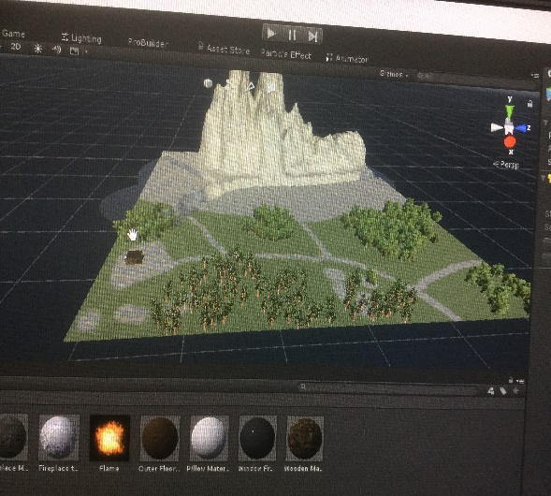

For my indoor section, I built a wooden cottage which I a material using height and normal maps in its materal. The cottage had a click to animate door for entry and exit. Inside the cottage was a fireplace which used paticle effects and indirect lighting with light probes for a brighter setting indoors.

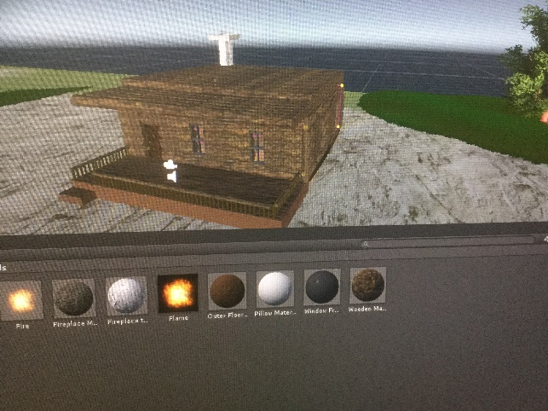

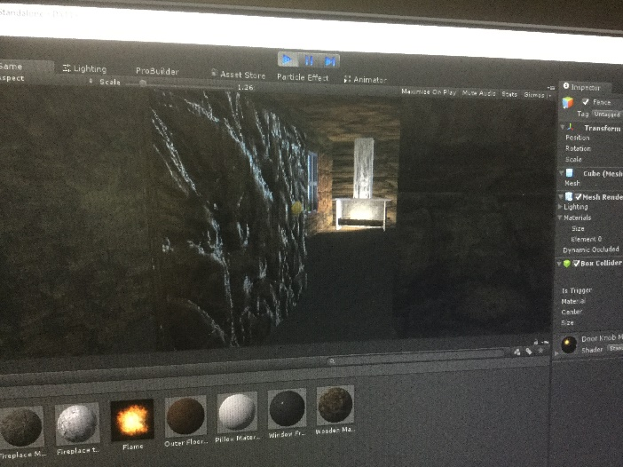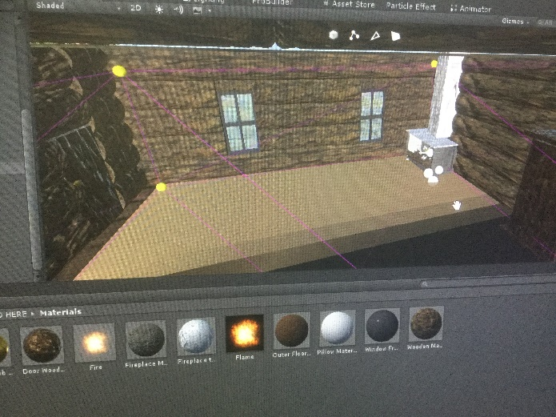

In addition to the entry door I also made a click to animate sliding door with these position coordinates.

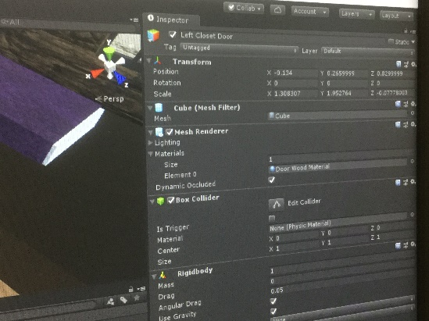

Closed

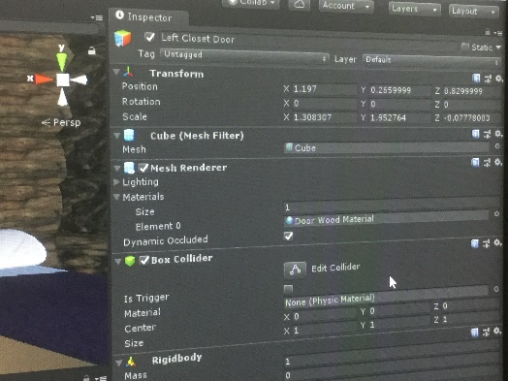

Open

Finally, for the indoor section I added a bed with a kickable physics pillow for the players to play around with as an Easter egg.

